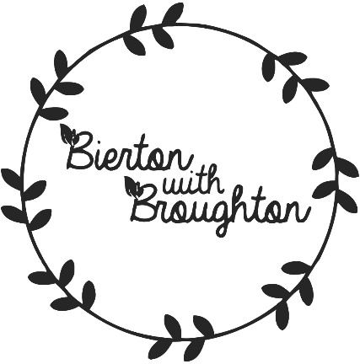

News Update

22nd October 2018
Thank you to everybody who was able to attend the Neighbourhood Plan Feedback Event on the 29th September 2018. It was a great turnout and makes all the work going on behind the scenes, to put the plan together worthwhile. All the information displayed at this event can be found here (add link to it on resources page)

