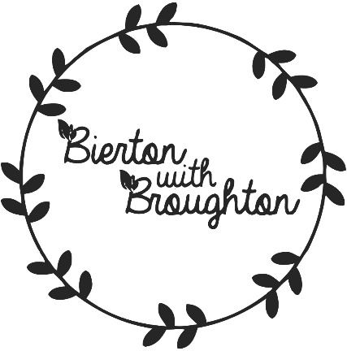

News Update

12th November 2020
​Throughout this year we have been working hard via Teams, behind the scenes to prepare the Neighbourhood Plan for the Regulation 14 Consultation. This will take place from the 2nd November - 13th December 2020. Information will be coming through your letterbox very soon.

